C211 Readings & Assignments: Week 5

Week 5 Reading
Complete the following reading early in the week:
- Week 5 and Week 6 online lectures
- From your course Textbook, Storyboards, Motion in Art, read the following chapters:
*Chapter 43: Pricing
*Chapter 41: How Productions Work
*Chapter 42: What Producers Look For
Week 5 Assignments Overview
Assignment Summary: Week 5 | Due Date
Assignment 1: Discussion Questions | Friday, December 12, 2008
Assignment 2: Final Project: Finalizing Storyboards | Sunday, December 14, 2008
Assignment 3: Final Project: Creating an Animatic | Wednesday, December 17, 2008
Remember that all assignment details can be found on the assignment pages located throughout the week. Go to those specific pages for direction on how to complete each individual assignment.

Managing Creativity
During the past four weeks you have learned various techniques and proven disciplines to expand your knowledge of the storyboard process. The focus this week is how to effectively bring thoughts and ideas into visual reality. This should help you make the most of your innovations as well as increase the level of your productivity.

Avoiding Production Problems
New and innovative ideas are essential for survival as a storyboard artist; but remember, an idea is only as good as your ability to see it through. It may appear fantastic in rough pencil but if it falls apart in production it is worthless.
Suppose you come up with an illustrative style that is "over the top," but it turns out to be a production nightmare because it takes too many steps to finish it as you envisioned. To avoid such a situation, complete a single frame of your idea. Then, before committing yourself, calculate how long the production might take if there were 720 frames. It is important to analyze what's involved to avoid finding yourself behind schedule and over budget.
We discussed sign-offs earlier in the course as a way to document approval for various stages of production; for example, you should have thumbnails approved before going to rough boards. However, doing this can sometimes work against you. Once you have approval for a certain creative style you have also made a commitment to complete the project in a specific manner. If circumstances force you to change the creative approach you proposed, it is likely to cause some disappointment. In other words, don't "bait and switch." People expect you to deliver what you sold to them. If at all possible give them more than they expect, but try to avoid giving them less.
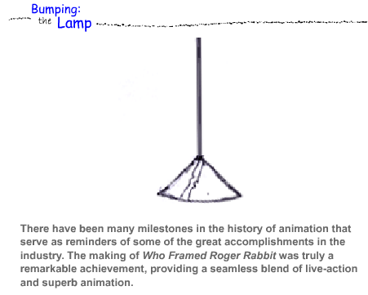
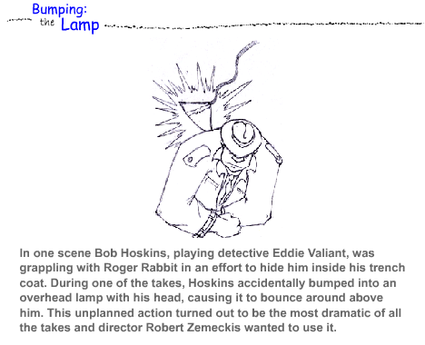
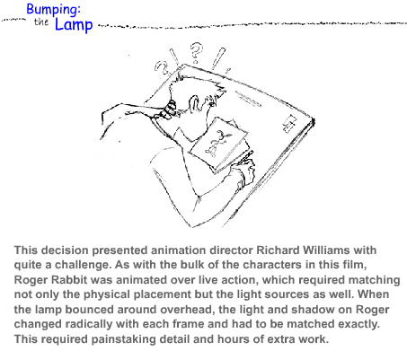
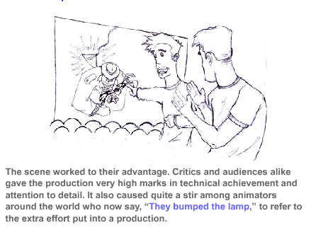
As you work on projects, the challenges you face can provide an opportunity to seize the moment and create something spectacular. Always be on the look out for your chance to "Bump the Lamp" whenever it is possible. In storyboarding, for example, continuously keep interacting with the director, animator, and other key people in the team to get their ideas and make sure the storyboards don't drift away from the intended direction. These interactions can provide you numerous opportunities to bump the lamp.

Keep Yourself Updated
New innovations in computer software and hardware make it possible to produce animation like never before. As technology expands, restrictions on the creative process are stripped away. In this age of computer-generated imagery, virtually anything you imagine can be produced visually.
With technology, competition has also increased exponentially. The leaders of the entertainment industry are constantly looking for new ideas that stand out. Every technique you master gives you an opportunity to offer your expertise to those in search of it. This expertise does not always come easily but it probably will not come at all to those who are not in pursuit of it. With every achievement generally comes an insatiable appetite for more.
Many opportunities await those willing to push themselves to go the extra distance. The fact that you are taking this course and reading this material indicates your willingness to invest time and resources towards improving your knowledge and expertise in this profession. Knowledge does not absolutely guarantee success, but it certainly goes a long way to improve the odds.
Continue cultivating new ideas and creative expression, explore new technology, pay attention to details, and increase your awareness of the world around you.

Timing and Spacing for Animation
Timing and spacing are the most effective techniques used by most entertainers. This holds especially true for animators and storyboard artists. There are certain tools that help ensure proper timing and spacing in an animation. Let's discuss them.

Bar Charts
You are now familiar with the various ways that storyboard development is approached, in particular, with or without a soundtrack. If circumstances require you to develop boards prior to soundtrack recording, it may become necessary for you to include bar charts to indicate how the scenes are to be timed out. Let's see how to use bar charts to our advantage.
Click on the graphic to download the PDF file. The first seven pages display a typical production storyboard and the last page contains a bar chart for the storyboard. The storyboard artist has timed out the action to ensure the animators capture the action as it is to occur. You will find this more common when sequences such as the one displayed here involve a voice over as opposed to spoken lines. A voice over consists of lines spoken off camera by someone such as an announcer. Spoken lines generally feature a character speaking on camera. Spoken lines must be animated with accurate lip synchronization, but voice over lines don't require animation. Instead, the storyboard artist must provide a guideline to indicate the proper way to time the sequence. This could involve pauses in the dialogue, music builds, sound effects, or any other treatment in the development of the soundtrack.

Developing Bar Charts
The first thing to recognize when preparing a bar chart is that the timings are not exact or calculated to the frame − they only need to be within a second or half of a second. The most common way to describe the timings is with a diagram similar to the one on the last page of the pdf file. The horizontal lines on the page represent time, and the action happening in the animation is described above it. Seconds represented on a single line vary according to the preference of the storyboard artist; some artists use 05-second lines, while others may use more. The example in the pdf file displays 06 seconds on each of the 3 lines, for a total of 18 seconds.
Notice the tick marks halfway between each second. These indicate where the beats and half beats are to occur. The artist calls for the sequence to cut at 16 ½ seconds. You will also notice that the artist has only described the action and the camera directions, leaving the timing of the dialogue up to the announcer. This allows the voice over to sound more natural with a steadier flow, as opposed to putting exact words at key frames; however, timing is a personal preference and may vary depending on existing circumstances. If the boards are to be converted to an animatic, the soundtrack can be recorded first, and then the visuals timed to fit it.

Lip Sync
Lip sync must be absolutely accurate and calculated to the exact frame. This assures accuracy to within a 24th or 30th of a second. When preparing lip sync, you should always record the voice-over artist first, and then animate the character to mouth the words and syllables as they occur on the soundtrack. This will require timing the soundtrack and converting the dialogue onto a readable Exposure Sheet or a timed printout from the recording studio.

Exposure Sheets
When a project progresses from the storyboard stage into production, one of the first things the animator prepares is an exposure sheet similar to the example in the graphic. The exposure sheet is an important component of the animation process, enabling the animator to identify each frame of the action, character levels, camera instruction and other vital information. In most cases the key frames for each action are identified on the exposure sheet at the appropriate time or at exact frame when the action occurs. This is especially true if lip sync is involved.
As an animator, you need to know the components of an exposure sheet. The top of the page is for the purpose of identifying the scene and may vary considerably from one studio to another. All of the other entries are industry standard and fairly universal around the world. Starting at the upper left you will see the following headings:
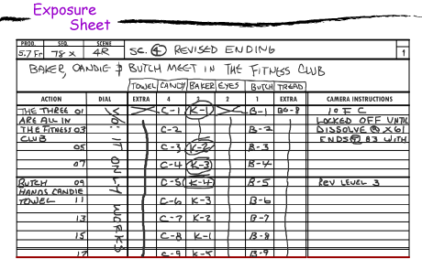
Most animators start by numbering the frames in a sequence. It is not necessary to number every frame. In this example the animator has identified every odd-numbered frame in the Action column.
There are two basic speeds to consider for timing action. A film runs at 24 fps (frames per second) and video runs at 30 fps. The sample in the graphic is set for film speed, indicated by 1 second on every 24th frame in the Action column. You will also notice the bold or double lines every eight frames. This, believe it or not, is a mathematical aid, which allows quick calculation in feet as well as seconds. Much like the bar charts, the bold lines represent foot and half-foot increments. One foot of 35mm motion picture film is 16 frames. Throughout the evolution of the animation industry, animators have been measuring their work in feet, as opposed to drawings or frames. The bold lines provide a quick reference to quickly calculate the feet in a sequence. The third bold line is obviously 1 second, calculated at 24 fps.
The first column is for describing the action. Pay particular attention to the frame counts to be sure you are describing the action at the exact time it is to occur. Any voice parts or sound effects are written in the DIAL column, with a certain amount of precision. The next six columns are for identifying artwork such as foreground drawings and backgrounds. The lowest numbers are on the lowest levels. This is to establish exactly where the drawings occur according to the frame count and which drawing is closest to the viewer.
The last column to the right is for camera instructions only and identifies with the exact position of the camera in the very first frame. Any changes in camera positioning or other cues must be identified in this column. The understanding of exposure sheets is as valuable to an animator as sheet music is to a musician. The more sophisticated, high-end animation software programs are all driven by exposure sheets. If you do not know how to communicate through exposure sheets, it will be difficult to composite your animation properly.
We have touched on the use of exposure sheets and may have repeated the things you are already familiar with, but it is important for you to understand that an action in an animation must be calculated to the exact frame. The more you are aware of the chain of events that occur when your storyboard goes into full production, the more effective you will become in developing your art.

Making Changes and Corrections
In the course of this study we have been dealing primarily with typical circumstances and the standard way objectives in the animation industry are attained. It is a fact of life, however, that projects do not always go smoothly. With that in mind, let's explore a few challenges you might encounter.

Changes and Corrections
Unless involved in the animation production process, there is a possibility that the storyboard artist will never need to work on the boards again after they have been approved. This is especially true if the production is being completed "off shore," as is the case with the majority of television programs. The artist finishes the boards, which are approved and sent into production. When the animation is completed the storyboards are returned and stored in the studio archives.
Considering the majority of the animation seen on television, the volume of work is almost overwhelming. One episode of an animated television series involves no less than 22 minutes of full production. A full season is made up of 26 episodes, which are run consecutively for the first 26 weeks of a year, then rerun for another 26 weeks. This makes up more than 12 hours of animation or, to be exact, 17,248 seconds—equating to well over 200,000 frames shot on 2s! These are staggering numbers for just one program, let alone for the hundreds of shows that are aired each year.
In light of the time it takes for production, a tremendous amount of work needs to be carried out in almost an assembly line fashion. So consider what must happen in this process if changes are made. For the most part, animation companies producing shows in volume will not accept verbal or even written changes unless they are extremely minor. Animation assembly lines required to churn out large volumes of finished scenes are not equipped to make any changes at this juncture. The boards are converted to final animation exactly as indicated, period! Changes in the storyboarding stage are fairly common and relatively inexpensive to make. But changes made during final production, however, pose significant problems and can slow down a production almost to a halt.

Budget Evaluation
Each situation involving redesigning of storyboards depends on individual circumstances. In the case that final storyboards for an episode or segment have been completed, a significant change could make it necessary to completely redraw the entire series of boards. As a consequence, someone is going to have to make up the lost design time. Studio or freelance storyboard artists should only be responsible for any mistakes they may have made. Otherwise, the producer or the party making the changes should be responsible for any production costs incurred.

Changes Impact the Deadline!
In addition to the impact on finances, changes or corrections also impact the timeline of a project. Even when the production expenses are resolved, consideration must also be given to how much time will be required to make changes. In many cases the start date is delayed yet the completion date is not. Each time this occurs deducts a certain amount of production time from the project. Always be aware of established deadlines and try to meet them. It can sometimes be difficult enough to meet a deadline when things go right. You don't need to be put in a position that makes this difficult or worse, impossible.

Compromise
In most cases, changes are for the better and have been seriously considered prior to being implemented, but there are always exceptions. A storyboard may have been executed perfectly. However if it comes back with changes that work against it you as a storyboard designer need to take a judgment call. If you find yourself in a similar situation, remember that you have been hired for the talent you bring to the table. At the very least you owe it to your employer to say that the concept has been compromised. And you should always be prepared to offer a solution or an alternate way to incorporate changes.

Holding Your Ground
Just because an individual is in a position to make decisions does not guarantee he/she will make the right decisions always. If you ever find yourself in a position to challenge a superior, make sure of one thing. Be sure you are right. In other words, do your homework well and don't take a stand unless you can defend it.
There may be circumstances when part of the established look of a production intentionally violates proven techniques. This was the case in the storyboard test you took in Week 3. A situation like this would not be the time to try to force a design in a different direction. The characters and overall look have been previously established, and you must respect this decision. As an effective storyboard artist you must learn to work with whatever you're given.

Wrapping up
During this week we have touched on issues such as improving your productivity, the value of timing and spacing, and how to deal with storyboard changes. While no two projects are alike and each will present its own set of challenges, always remember that creative people are problem solvers by nature.
Make the best of every opportunity and continue to learn as much as possible in order to meet your goals.

Assignment 1: Discussion Questions
By Friday, December 12, 2008, respond to the discussion questions assigned to you by the facilitator. Submit your responses to the appropriate Discussion Area. Start reviewing and responding to your classmates as early in the week as possible. Be clear and concise in your comments.
Assignment 1 Grading Criteria and Respective Point Value | Maximum Points
Response Criteria
Met the criteria for the correct responses to the questions assigned | 4
Used vocabulary relevant to the current week's topics - at least four terms | 4
Participation Criteria
Used vocabulary relevant to the current week's topics - at least four terms | 4
Participated in the discussion by asking a question, providing a statement of clarification, providing a point of view with rationale, challenging a point of discussion, or making a relationship between one or more points of the discussion | 4
Justified ideas and responses by using appropriate examples and references from texts, Web sites, and other references or personal experience | 4
Total: | 20
For assistance with any problems you may have when completing this assignment—OR—to offer your assistance to classmates, please use the Problems and Solutions Discussion area located through the left side navigation link.
Please respond to two (2) questions provided. Please, post your assignment here in Discussion Thread. Thank you Andrzej
DQ 1 - Search the Web for examples of incidents that created noticeable budgetary impact on production and share them with the team. You can find examples from areas of filmmaking, gaming, or broadcast animation. Discuss how these incidents could have been avoided. How important do you think is the role of a storyboard in keeping production within budget and why?
DQ2 - You are involved in developing the concept and creating storyboards for an animation film whose production is completed in another country. The film has not turned out as expected. A detailed analysis reveals that there were incorrect instructions and timing in the storyboards. Perhaps an animatic should have been created and sent along with the storyboards for the production phase. But now the deadline is just round the corner. How will you address this issue? Using the Discussion Area, create a conversation between yourself, as the storyboard artist, and a classmate as the client.
DQ3 - Does technology inspire creativity or creativity inspires technology? Discuss your ideas with the class.
DQ4 - Discuss the problems you are facing in your work on the Final Project. Share with the class how you plan to solve these problems. Also suggest solutions to problems faced by other students and better and faster ways of completing things.
DQ5 - Using the person you were teamed with as the client or storyboard artist, post your critique of how well the storyboard worked for you. Use the Discussion Area as a way of documenting the questions and responses that a client and a storyboard artist would have conversed.

Assignment 2: Final Project: Finalizing Storyboards
By Sunday, December 14, 2008, review and critique the storyboards submitted by other students in the storyboard assignment from Week 4 in the Discussion Area. Improve your own storyboards based on suggestions or justify your work if you feel the comments are not valid. Resubmit the modified storyboards to the W5: Assignment 2 Dropbox by the end of the week.
Assignment 2 Grading Criteria and Respective Point Value | Maximum Points
Provided constructive criticism | 4
Provided logical justification for improvement of storyboards | 4
Showed noticeable improvement | 4
Total: | 12
For assistance with any problems you may have when completing this assignment—OR—to offer your assistance to classmates, please use the Problems and Solutions Discussion area located through the left side navigation link.
Please post your critiques here in Discussion Thread.

Assignment 3: Final Project: Creating an Animatic
Using the existing storyboard from the previous assignment, create a finished animatic and post it to W5: Assignment 3: Dropbox by Week 5, Day 7. Include an explanation if you have made any changes that depart from your original concept. Include appropriate music, sound effects, and voice track if required. Use only the music that is free on the Web.
Note: You can refer to the following URL for examples of animatics:
http://www.animaticmedia.com/
Note: Discuss any challenges you encounter in this assignment or any other assignment in this course in the Problems and Solutions Discussion thread. Also share useful tips and tricks and possible solutions to problems posted by your peers in this forum.
The Problems and Solutions Discussion thread will be present each week. Therefore take advantage of this discussion forum as much as possible.
Assignment 3 Grading Criteria and Respective Point Value | Maximum Points
Followed previous storyboard and provided detailed explanation when deviating from the storyboard | 4
Ensured that camera cuts, dissolves, etc. flowed with the soundtrack | 4
Enhanced the action with sound FX that did not dominate | 4
Actively participated in the Problems and Solutions discussion forum | 4
Total: | 16
For assistance with any problems you may have when completing this assignment—OR—to offer your assistance to classmates, please use the Problems and Solutions Discussion area located through the left side navigation link.

